Obstacle Avoidance Robot Using Ultrasonic Sensor
Saurabh Jasiwar

Undergraduate Students-Bsc IT
Bunts Sangha’s
Anna Leela College of
Commerce and Economics
Shobha Jayaram Shetty College
Of BMS
Mumbai, Maharastra,400070,
India
Saurabhjaiswar211@gmail.com
Shaikh Daniyal

Undergraduate Students-Bsc IT
Bunts Sangha’s
Anna Leela College of
Commerce and Economics
Shobha Jayaram Shetty College
Of BMS
Mumbai, Maharastra,400070, India
skdaniyalajaz@gmail.com

Sahajeb Qazi

Undergraduate Students-Bsc IT
Bunts Sangha’s
Anna Leela College of
Commerce and Economics
Shobha Jayaram Shetty College
Of BMS
Mumbai, Maharastra,400070,
India
qazishajeb@gmail.com

Prof. Dhanraj Jadhav
Assistant Professor-BSc IT Bunts Sangha’s College of
Commerce & Economics,
Shobha Jayaram Shetty College
Of BMS
Mumbai, Maharashtra, 400056,
India
jadhav.dhanraj2007@gmail.com

Abstract—This paper illustrates the design and development of an autonomous obstacle avoiding robotic car controlled by an Arduino in conjunction with ultrasonic sensors. The system is capable of detecting and processing obstacles so that the robot can navigate them without assistance from a human operator. Control as well as algorithms for the robot's obstacle detection and avoidance are reliable for navigation in different environments. Their applications consist of autonomous delivery systems, security robots, smart vehicles, which can be integrated with high level of modernization based on machine learning, and IoT. The tests results proof of its functionality and effectiveness for real world applications.
Keywords-Microcontroller, Sensor, Motor Driver, Motor, Power Supply, Miscellaneous Components;

INTRODUCTION
In the last few decades, the field of robotics has advanced significantly and its applications include the production medical items, the manufacturing industry, agriculture and even transportation. Autonomous systems allow for a greater level of efficacy, security and output, while robots designed for avoiding obstacles are crucial for erratic systems. This innovation is in fact robotic cars that can detect and avoid barriers by themselves, and can be employed in areas such as those that require minimal human contact to function. Autonomous cars that avoid obstacles are powered by a combination of sensors, microcontrollers, and navigation software. For example, ultrasonic sensors are able to spot and alert the microcontroller which in turn, ideally an Arduino, guides the robot through its programmed destination. The employs a number of fields from autonomous driving cars to delivery packages and searching and rescuing lost ones. This development has a lot of integrating fields such as electronics, programming as well as mechanical design. These systems include ultrasonic sensors which help in detecting, motor drivers that help in movement and microcontrollers that helps in decision making. This has been made possible by Arduino based systems that are easy to use, thus can be applied in extensive profiting among students and researchers. Urban delivery services and disaster response, in which navigation through debris-filled environments is required, are applications of these robots. These key challenges can be solved through HW - SW coordination and systematic design along with the complex ones like accurate obstacle detection, efficient path planning and adapting to terrain. Autonomous and self-controlling robots which are designed for obstacle avoidance have seen improvement in their functionality due to technological advancements like machine learning and IoT. An Arduino based sensor centric robot for obstacle avoidance is designed, constructed and programmed that would later serve as a base for more complex robotic applications at a reasonable price. The remaining sections describe the approach, the actual work done, and the achieved results and their analysis, performance of the robot within different scenarios, its strengths, and limitations and the modifications proposed. It is this context that we looked at, how this review could potentially drive innovation and creativity in the field of robotics and spark interest in some practical, easy to implement ideas.

LITERATURE REVIEW
The problems of obstacle avoidance in mobile robots have had an extensive study with solutions provided for better autonomous navigation. A growing preference is emerging for ultrasonic sensors in obstacle detection on mobile robots, given their low cost, reliability, and ease of integration. Research into augmented reality in this area originated in the early works on navigation. In these works, an immense contribution was made by Khatib[1], in 1986, where he published works on the artificial potential fields (APF) method-the barriers repel and the target-attracts the robot. But, this method has some inherent disadvantages: the local minimum problem. So the robot will stuck in a particular configuration and cannot proceed further. Borenstein and Koren[2] in 1991 overcame this basic drawback with the introduction of the Vector Field Histogram (VFH) technique. This reduces the effect of sensor noise on effective real-time path planning, thereby enhancing the robot's obstacle avoidance.

Ultrasonic sensors have found extensive applications in mobile robots owing to their capacity for real-time obstruction detection. More precisely, Al-Mamun et al. (2019) mention that theirs is one of the systems that struggled with detecting small or very reflective objects. Thus, Patel and Mehta (2021) proposed an avoidance system for a barrier based on a PID control system for increased accuracy, improving response time, and smooth vehicle navigation. Even with the advantages mentioned above, ultrasonic sensors have limitations, such as the detection of soft surfaces and noise interference from the environment. In 2017, Son and Bake presented a hybrid detection system in which these limitations were combined with infrared and ultrasonic sensors to enhance robustness by compensating for the individual weaknesses of each sensor type.

Recent studies incorporate fusion technology and AI in the detection of obstacles and evasion of actions. Ultrasonic sensors combined with Lidar are used, as noted by Singh et al. [6] (2020), and prove helpful in greatly advanced obstruction automation in particularly intricate settings. Their research that was conducted verified that the ultrasonic sensors indeed provide accurate range data within short radiuses and that the lidar serves to increase range identification as well as preventing further obstructions from easier methods. Gupta et al. [7] (2022) suggested the recognition impairment by training a robot with a dataset containing numerous different obstacles through an intensive learning based approach. The results suggested that AI-managed detection of the aforementioned obstructions have undergone a paradigm shift towards increased accuracy and adaptation capability. Moreover, Zhang et al. [8] (2021) applied reinforcement learning where a robot could be trained through past experiences of navigating the environment in real-time, thus increasing the robot’s ability to use real-time decision making in proactive settings.

Even if there have been improvements, there still seem to be issues with ultrasonic sensors toward avoiding an obstruction: false alarms, low detection radius, and inability to discriminate transparent or shiny objects. Research focuses on integrated hybrid sensor schemes, AI-based reasoning, and optimization techniques to improve obstacle-avoidance capability. Currently, the focus is on expanding sensor technologies, such as lidar, stereo vision cameras, and 3D mapping, to enhance environmental perception. Alternatively, the AI model could enhance the efficiency of the system by using deep reinforcement learning to train the robot to effectively navigate dynamic-world obstacles. So to put it all together, lots of work still remains on the AI sensors; however, the AI reinforcement learning autonomous robot using a hybridization of sensors is truly destined to give the most unique solution for obstruction in robotic navigation.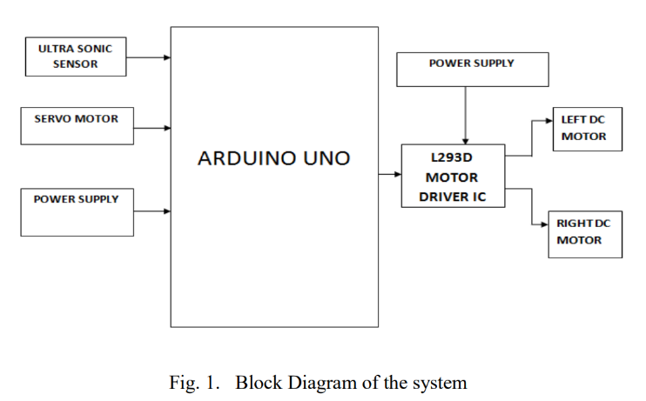

METHODOLGY
- Overview
In configuring it for the mobile robot, Arduino Uno Microcontroller with L293D motor driver IC, four DC motors, HC-SR04 ultrasonic sensor, and servo motor are used to control basic functions of the robot due to the purpose of the setup concerning the detection of obstacles by the sensor towards building an autonomous robot with avoidance capabilities. A 9V battery is used to operate the circuit, whereby the motor driver gets its power from it, while the Arduino circuit can be powered by either a USB or the onboard external power supply.

- Central Control with Arduino Uno
The Arduino UNO is the primary processing unit of the system where the HC-SR04 controller collects data from the ultrasonic sensor and uses it to send control signals to the motor driver and servo motor. The L293D motor driver controls four DC motors and allows the robot to move forward, backward, or sideways depending on input from the ultrasonic sensor. Since direct interfacing of the motors to Arduino is not possible owing to current rating limitations, a separate motor driver is required to control the working of the motors using control signals from Arduino.

- Obstacle Detection Using Ultrasonic Sensor
The working of the system is very simple as it can connect the ultrasonic sensor to the Arduino board directly at VCC, GND, Trig, and Echo PIN. This robot measures the time it takes to send the ultrasonic pulse and have the pulse bounce back after hitting a barrier to calculate distance. After processing this data, a decision is made by the robot. Whenever there is an obstacle within set thresholds, the robot stops to evaluate a course of action to avoid collision.

- Environmental Scanning with Servo Moto
A servo motor is included in the circuit to allow for rotation of the ultrasonic sensor to optimally scan the surroundings for better robot navigation. Being under PWM pin control from Arduino, the servo motor gets its position changed by signals from the Arduino. By turning the ultrasonic sensor left, right, or up, the robot can analyze any obstacles in the direct checkerboard grid pattern in front of it to intelligently decide on movement based on whether an obstacle exists left, right, or straight ahead.

- Power Distribution
The assembly uses an L293D motor driver IC, four DC motors, an HC-SR04 ultrasonic sensor, and a servo motor to control the movement of a robot vehicle that can operate autonomously. It is designed to create an obstacle-avoiding robot. Regarding the power supply, the circuit gets powered from the Arduino through USB or using its onboard power supply, while a 9V battery powers the motor driver.

- Programming and Functionality
The activities of the robot are governed through an Arduino program that reads sensor values and modifies motor action in real time. In case the sensor perceives an obstacle within a preset range, the Arduino ceases motor functions and pivots the servo in order to observe the area. After the area has been scanned, the robot makes a decision on the optimal movement direction and turns on the motor driver. This propels the robot to traverse freely while actively evading barriers in its way.

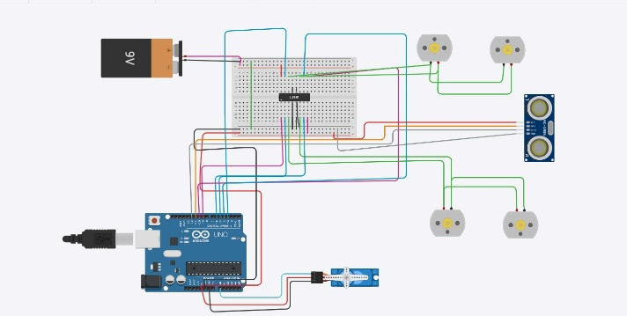

RESEACH FINDING AND ANALYSIS

This analysis investigates the effectiveness, precision, and challenges of an autonomous obstacle-avoiding robot built with an Arduino Uno, an L293D motor driver, a HC-SR04 ultrasonic sensor, a servo motor, and four DC motors. The analysis shows the system’s capabilities of obstacle detection and navigation performance, power utilization, and pinpointing improvement areas.

Efficiency of the System: The robot can detect and avoid obstacles with the help of the HC-SR04 ultrasonic sensor and servo motor that can enhance scanning. The thorough movement is provided by the L293D motor driver while the Data from the robot is processed by the Arduino Uno at slow lag. The motor driver is powered effectively and directly with a 9V battery while other components get their voltage supply from the Arduinos 5V port.

Accuracy of Obstacle Detection: The HC-SR04 can measure distances accurately, up to a margin of 3mm. It does, however, struggle with lower range absorptive or angled surfaces that do not reflect ultrasonic waves properly. The servo motor scans a wider area which helps in eliminating blind spots.

Motor Performance and Navigation: Movement and rotation are made seamless due to four connected DC motors, and the servo motors are operated by L293D motor driver. The motor driver is able to augment power through the usage of PWM signals to change the rotation speed of the motors; although, these motors had some traction problems on rough terrains. The use of rubberized wheels or a more powerful motor driver like L298N or TB6612FNG could help with traversing surfaces more effectively.

Response Time and System Latency: Through the use of the ultrasonic sensor, real-time feedback can be received which allows for the quick detection of an obstacle as well as movement adjustment. This quick feedback can set off reaction delays from the sensors or the speed of the servo, which may take some time. The robot manages to react and respond seamlessly within milliseconds which allows for the aid of efficient navigation.

Limitations and Potential Improvements:

Limited detection range (2cm-400cm) – Adding infrared sensors or LiDAR could enhance detection.

Difficulty detecting transparent/absorbent object- Optical sensors may complement ultrasonic detection.

Motor efficiency – A more powerful motor driver (L298N, TB6612FNG) could improve control.

Wireless control – Adding Bluetooth or Wi-Fi would allow remote operation.

CONCLUSION

The Research indicates that the autonomous robot uses ultrasonic sensors for obstacle avoidance, alongside servo motors that operate in conjunction with the L293D motor driver for smooth movement. Obstacle detection is performed by the Arduino Uno, which then makes quick decisions after processing input from the ultrasonic sensor. Yet the robot has shortcomings in terms of power consumption, sensor accuracy, and variable terrain conditions.

Optional equipment would include the motor drivers L298N and TB6612FNG, a wider selection of sensors like infrared and LiDAR, and a larger capacity battery for improving the machine. Bluetooth and Wi-Fi communications together with AI navigation will provide additional expansion capabilities for the robot.

In conclusion, this project establishes a certain foundation for the much more complicated autonomous navigation system that will be improved on.

REFERENCES

- Johann Borenstein, Yoram Koren, “Obstacle Avoidance With Ultrasonic Sensor.”, IEEE Journal Of Robotics And Automation, Volume.4, No 2, April 1988.

- Pavithra A C, Subramanya Goutham V, “Obstacle Avoidance Robot Using Arduino.”, International Journal of Engineering Research & Technology (IJERT), ISSN: 2278-0181, Special Issue – 2018.

- Karl Norén, “Obstacle Avoidance for an Autonomous Robot Car using Deep Learning.”, Linköping University, Issue – 2019.

- Vinay Kumar, B. Rakesh, S. Shyam, Manjula, “Obstacle Avoidance Robot Using Arduino.”, J B Institute of Engineering and Technology Autonomous College, Volume 8, Issue 6,June 2021.

- Akash Das, Avishek Ray, Animesh Chandra, “A Real time Obstacle Detecting and Avoiding Car.”, Department of Electronics and Communication Engineering, Institute of Engineering and Management, Vol. 2, Issue 2, 2021.

- Vishwa Priya V, Gokul S, Jeevanandham M B, Sanjay Johnson W, Sri Ram R T, Surya Prakash L, “Obstacle Avoidance Robotic Vehicle.”, Robotics and Automation Engineering PSG College of Technology, ISSN: 3412 – 3421, 2021.

- Siddhartha Tripathi, Vasu Tyagi, “Saksham, Design and Fabrication of Obstacle Avoiding Robotic Vehicle”, International Research Journal of Engineering and Technology (IRJET), Volume 09, Issue 05, May 2022.

- Rahul Dahale, Rani Chaudhari, Mandar Bathe, Adesh Chavan, “Robot for Obstacle Avoidance”, International Research Journal of Modernization in Engineering Technology and Science, Volume 05, Issue 05, May-2023.

- Akshad Shelar, Tulsi Waghmare, Kumkum Waghmare, “Obstacle Avoiding Robotic Car.”, International Research Journal of Modernization in Engineering Technology and Science, Volume 05, Issue 05, May-2023.

- M. Rohith, M. Rakshith Varma, B. Naveen, D. Lickith, K. Kranthi Kumar, “Obstacle Detection and Avoidance Robot.”, International Journal for Advanced Research in Science & Technology, ISSN 2457-0362, Volume 13, Issue 06, June 2023.

- Babatunde O Ayobami, Monday F. Ohemu, Alex Aligbe, Opeyemi O Adekogba, Zuleihat O. Zubair, “Implementation of an Obstacle Avoidance Robot for Surveillance.”, International Journal for Advanced Research in Science & Technology, ISSN: 2394-3696, Volume 10, Issue 7, July -2023.

- Muhammad Ahmad Baballe1, Mukhtar Ibrahim Bello, Shehu Hassan Ayagi, Umar Farouk Musa, “Obstacle Avoidance Robot using an ultrasonic Sensor with Arduino Uno.”, Global Journal of Research in Engineering & Computer Sciences, ISSN: 2583-2727, Volume 03, Issue 05, October 2023.

- Tanjim Mahmud, Israt Ara, Rishita Chakma, Mohammad Shahadat Hossain, Dilshad Islam, Koushick Barua, Karl Andersson, Anik Barua, “Design and Implementation of an Ultrasonic Sensor-based Obstacle Avoidance System for Arduino Robots.”, International Conference on Information and Communication Technology for Sustainable Development, September 2023.

- Akanksha Dash, Amrutha G., Krutika S. Ganpur, Sneha Chatter, Dr. Pavithra G., Dr. Sindhu Sree M., Dr. T.C. Manjunath, “Obstacle Avoiding Robotic Car Using Arduino with Bluetooth and Voice Control.”, Tuijin Jishu/Journal of Propulsion Technology, ISSN: 1001-4055, Vol. 44 No. 3 (2023).

